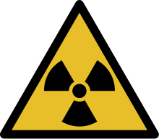

RADIOLOGICAL EXAM

Information

Please, pay attention!

Radiological test, using x-rays, will be carried out in order to verify the identity.
X-rays could cause biological damage to the irradiated tissue and they are not without risks. Indeed, natural radiations normally present on Earth can be the cause of a little part of genetic mutations (with fetal malformation) and of cancers that can be found in the population.
The exposure to x-rays for medical reasons represent the main source of exposure to artificial radiations for the population and for this reason it must be minimized.
These tests are justified by the need of a bone age verification not obtainable with other methods. Among radiations, X-rays are the most common and they use a low quantity of radiations with a risk that can be defined negligible.

Pregnancy or suspected pregnancy:

If you are pregnant or if you think to be pregnant, please inform immediately the staff.

